Visit Report: Raipur Upazila Health Complex, Lakshmipur
Date of Visit: 12/08/22; Time: 9:30 AM.
Visitor: Dr. Md. Emdadul Haque, National Consultant (HEU) &
Dr. Nazmur Rahman Sajib, Junior National Consultant (HEU)

1. We arrived in Raipur UHC at 9:30 am. The UH&FPO and RMO were waiting at the gate to welcome us. They escorted us to the conference room of the UHC. All consultants and medical officers were present. We discuss with them about the overall situation of the health complex. There are 10 unions under the UHC having 3,13,760 populations. There is one Sub-centre, 7 H&FWC and 17 Community Clinic in this Upazilla.
2. The infra-structure of this Upazila Health Complex is 50 bedded.
3. All the post of Consultants are vacant. So caesarean section is not being performed.
4. There is no cycle stand. There are many motorcycles parked in the premises.
5. We observed emergency, outdoor, pathology and pharmacy department. The information display system was weak.
6.The USG, ECG machine is functioning but X-Ray machine is not functioning.
8.The spaces of emergency is congested. But SSK Booth and Pharmacy cannot be established close to the emergency department. There is no separate O.T
9. Cleanliness of the hospital premises, outdoor and indoor was not satisfactory, but wash room was not clean.
11.The roof of the health complex is not clean. There are many bushes on the roof.
12.There are many “Danbox” throughout the UHC, and advised for removing those immediately.
14. In 2021, total OPD patient was 24,620, in emergency 6152 and in indoor admitted patient was 5878. Bed occupancy rate was 63%. Total ANC 1st visit in 2021 was 302 and total delivery was 46.
Health Profile:
Total population: 94,036
Union: 4 Sub-centre: 0 FWC: 4 Community Clinic: 08

Human Resources: 50 Bedded Hospital:
Sl. | Designation | No. of Post | Present | Vacant
1. | UH&FPO | 01 | 01 | 0
2 | RMO | 01 | 01 | 0
3. | Junior Consultant | 10 | 03 | 07
4. | Medical Officer (incl. sub-centre) | 08 | 07 | 01
5. | MO(Dental) | 01 | 0 | 01
6. | Medical Officer (OSD) | - | - | -
7. | Nurses | 31 | 22+1 in deputation outside | 08
8. | Mid wives | 04 | 03 | 01
9. | Medical Technologist (Lab) | 03+1 | 02+1 | 01
10. | MT EPI | 01 | 01 | 0
11. | MT(Dental) | 01 | 01 | 0
12 | MT (Radiology) | 01 | 0 | 01
13. | SACMO (UHC + Field) | 08 | 03 | 05
14. | Pharmacist | 02 | 01 | 01
15. | Health Inspector (HI) | 02 | 01 | 01
16. | Sanitary Inspector | 01 | 0 | 01
17. | Assist. Health Inspector | 06 | 03 | 03
18. | Health Assistant | 30 | 19 | 11
19. | CHCP | 17 | 15 | 02
20. | Head Assistant | 01 | 0 | 01
21. | Cashier | 01 | 0 | 01
22. | Accountant | 01 | 01 | 0
23. | Statistician | 01 | 0 | 01
24. | Office Assistant /Comp. Operator | 03 | 0 | 03
25. | Store Keeper | 01 | 0 | 01
26. | Cardiographer | 01 | 01 | 0
28. | MLSS+ Ward boy | 04 | 01 | 03
29. | Cleaner | 05 | 03+ 1 in deputation outside | 01
30. | Guard | 02 | 02 | 0
31. | Gardener | 01 | 01 | 0
32. | Cook | 02 | 0 | 02
33. | Attendant (Lab, Emergency, OT) | 03 | 03 | 0
34. | Driver(Ambulance) | 01 | 01 | 0
35. | Outsourcing: Driver | 01 | 01 | 0
36. | FWA | 39

Status in HSS Score From Jan-July.
Name | Jan | Feb | Mar | April | May | June | July | Aug
Lakshmipur District Hospital | 2 | 1 | 2 | 2 | 3 | 3 | 55 | 55
Raipur UHC | 87 | 121 | 127 | 306 | 228 | 92 | 358 | 374
Ramganj UHC | 31 | 4 | 13 | 75 | 83 | 120 | 364 | 372
Kamalnagar UHC | 154 | 119 | 59 | 176 | 168 | 289 | 385 | 380
Ramgati UHC | 196 | 117 | 96 | 265 | 219 | 212 | 356 | 369

Status of Building Blocks of C-J Model in the Betagi UHC:
Sl | Criteria of C-J Model | Satisfactory | Average | Not Satisfactory
01 | Cycle stand close to the main gate |  |  | √
02 | Health Education |  |  | √
03 | Cleanliness & beautification |  |  | √
04 | Separation of patients in out door & indoor |  |  | √
05 | Blood doner list with 24/7 B.T facility |  | √
06 | Birth- death recording |  |  | √
07 | Reception Desk |  |  | √
08 | Developed Emergency Dept. |  |  | √
09 | 5S –KAIZEN implementation. |  |  | √
10 | Community Participation. |  | √
11 | Hospital activities Display |  |  | √
12 | Corner based service. |  | √
13 | Cash counter for receiving Govt money. |  |  | √
14 | Devolped maternal health/labour word. |  |  | √
15 | Devolped paediatric health |  |  | √
16 | Position in HSS score in July22.  (Best= <100; Good= 101-200; Weak= >200) |  |  | √
17 | Power point Presentation &Video on UHC |  |  | √
18 | Knowledge about 8th Five Year plan & SDG. |  |  | √
19 | Zero-Tollarance on corruption |  | √

Recommendations:
1.Reconstruction of the old building must be start immidiately.
2.The post of gynae and anesthesia consultant should be filled up immediately for the development of improved maternal health.
3. Cleanliness and beautification is satisfactory. The local Powroshova must take part in waste management as health complex paid 15,00,000 Tk/year to Powroshova.
4. There should be funtioning OT room for major operation in the health complex.
5. Condemetion Board should work to destory all unwanted items.
6. All the vacant posts of 4th class should be fulfilled immediately.
7. The post of Dental Surgeon and Medical Technologist (Dental), Medical Technology (Radiology)must be fulfilled to start dental& radiology services.
8. Replication of C-J model will help in development of the quality of care and it should be followed properly.
9. There should be a Complaints and Suggestion box in front of UH&FPO room
10. The roof of the health complex building should be cleaned.
11. There should be availability of safe drinking water.
12. All the “Danbox” of the UHC, should be remove.
13.The performance of all services must be improved, because of underutilization of the health complex.

Photos of UHC, Betagi taken from the visit are shown below:
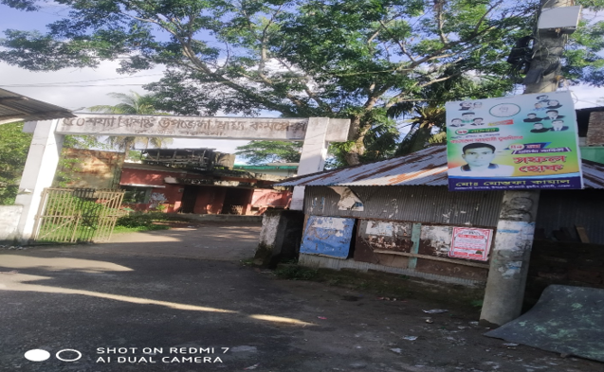
Figure: 01 Gate of the Upazila Health Complex is not identifiable, Betagi, Barguna.
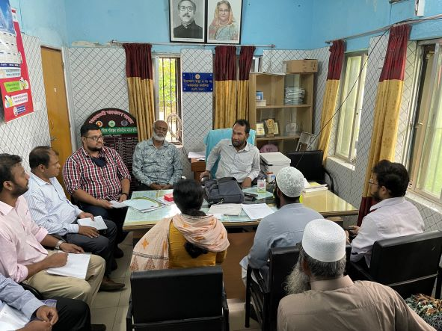Figure 2: Meeting with RMO & MOs in UH&FPO room
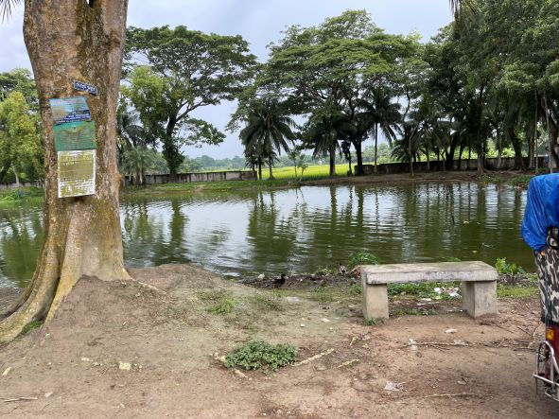
Figure 3: Campus is unprotected due to broken boundary wall.
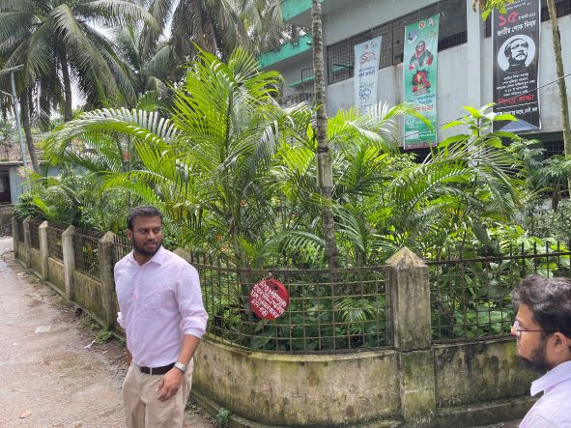Figure 4: Garden in front of the hospital (good practice)
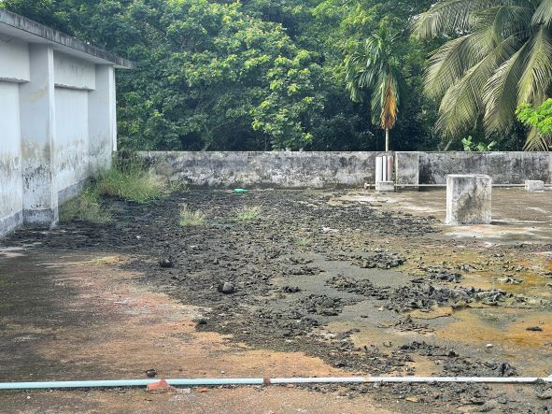Figure 5: Unclean roof of the hospital building
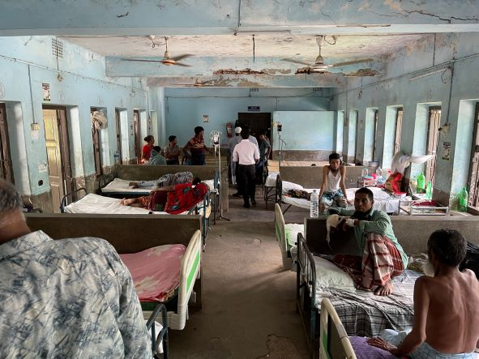
Figure 6: Unclean male medicine ward with chances of brake down of the roof.

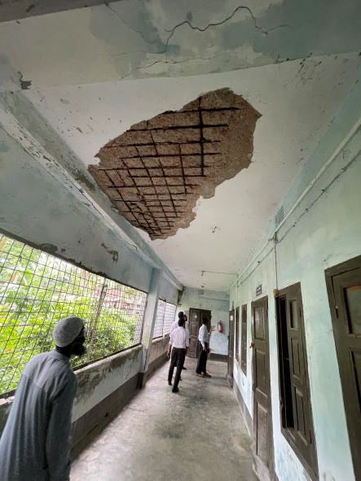Figure 7: In secured corridor of the hospital
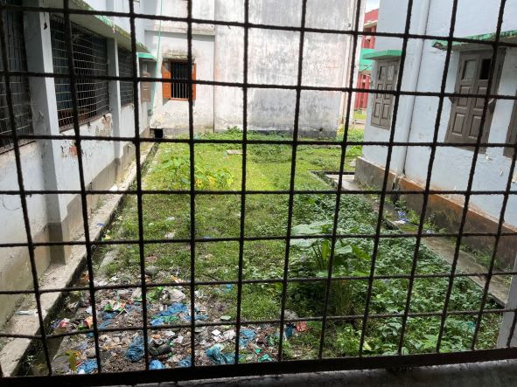Figure 8: Weak waste management system of the hospital
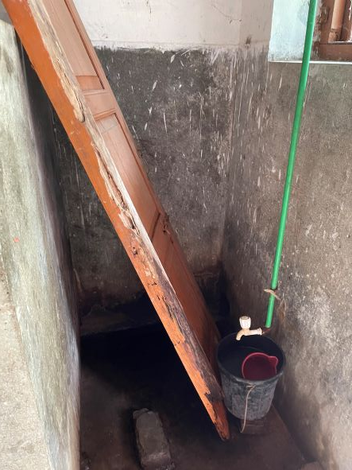Figure 9: Unclean washroom and proper privacy is not maintaining.
am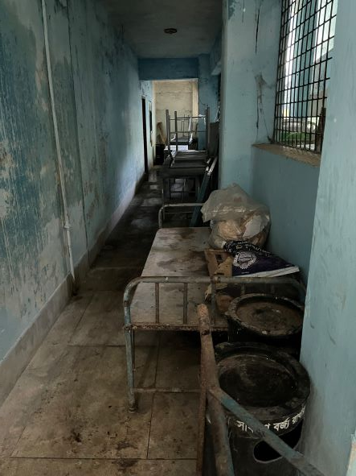BFigure 10: Unwanted items in corridor

